Tableau Project Solutions

XYZ company client performance data. needs to look back to its historical performance and business cycle in a way that will provide some meaningful information to take the strategic and informed decision for its expansion.

The management of XYZ wants to outsource this task, to analyze the trend, pattern, forecast, and analysis.

XYZ Client Performance

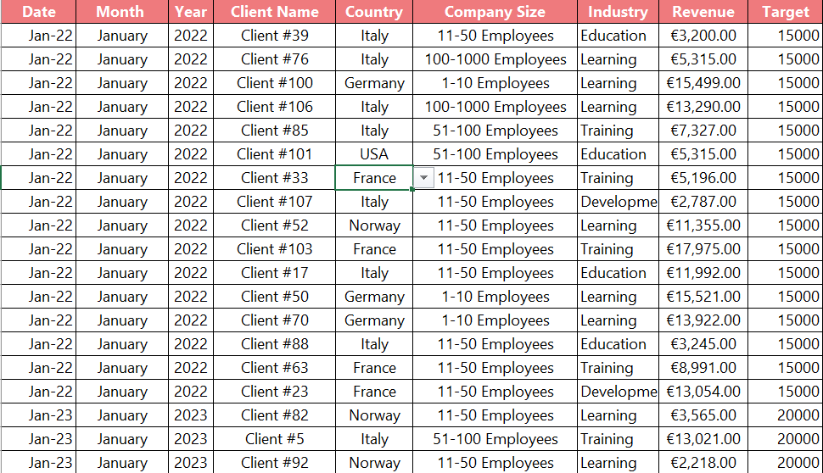

**Visual Insights**

* 1. Make number cards for the total customer, total target, and total income.

Like:

***Step1****: Drag the target field into the text* ***Step2****: Click on Text then Alignment “Center”* ***Step3****: Entire View*

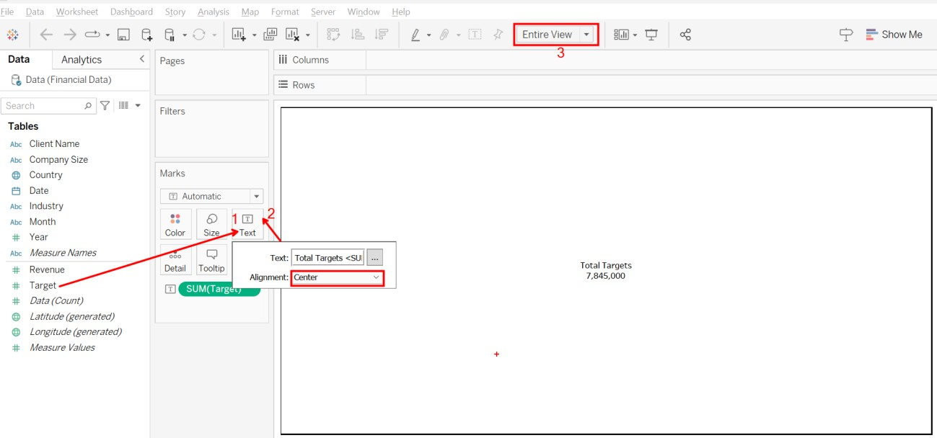

* 1. Make a Area chart that compares the firm target size to revenue.

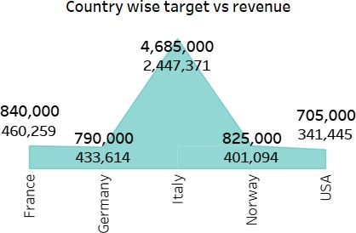

Like:

***Step1:*** *Drag the Country field into the column area* ***Step2:*** *Drag the Target field into the row area* ***Step3:*** *Drag the Target field into the text area* ***Step4:*** *Drag the Revenue field into the text area*

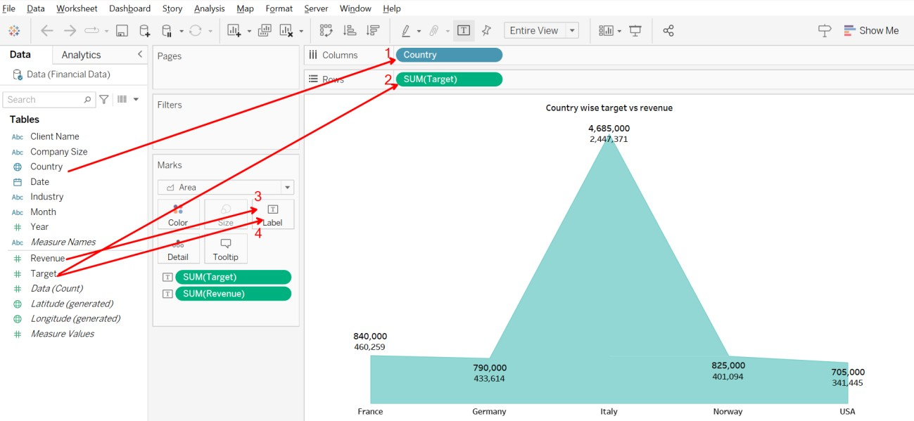

* 1. Make a pie chart that compares industry-specific revenue.

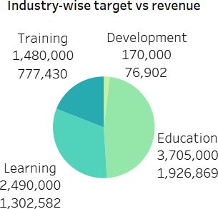

Like:

***Step1 & Step 2****: Drag the revenue & target field into the Label cards*

***Step 3****: Drag the Industry field into the Color cards*

***Step 4:*** *Select Pie Chart from “Show me”*

***Step5:*** *Select Entire View*

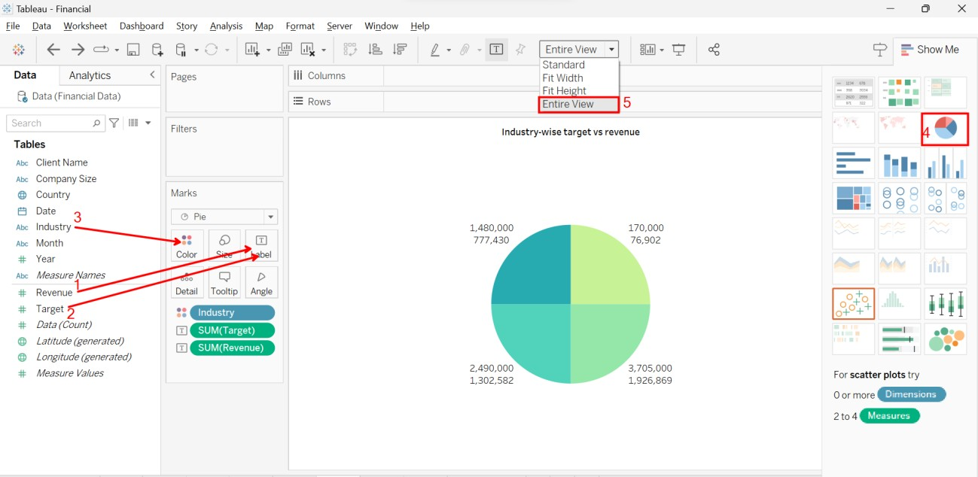

***Step 6:*** *Drag the Industry, Target, and Revenue field into the Label*

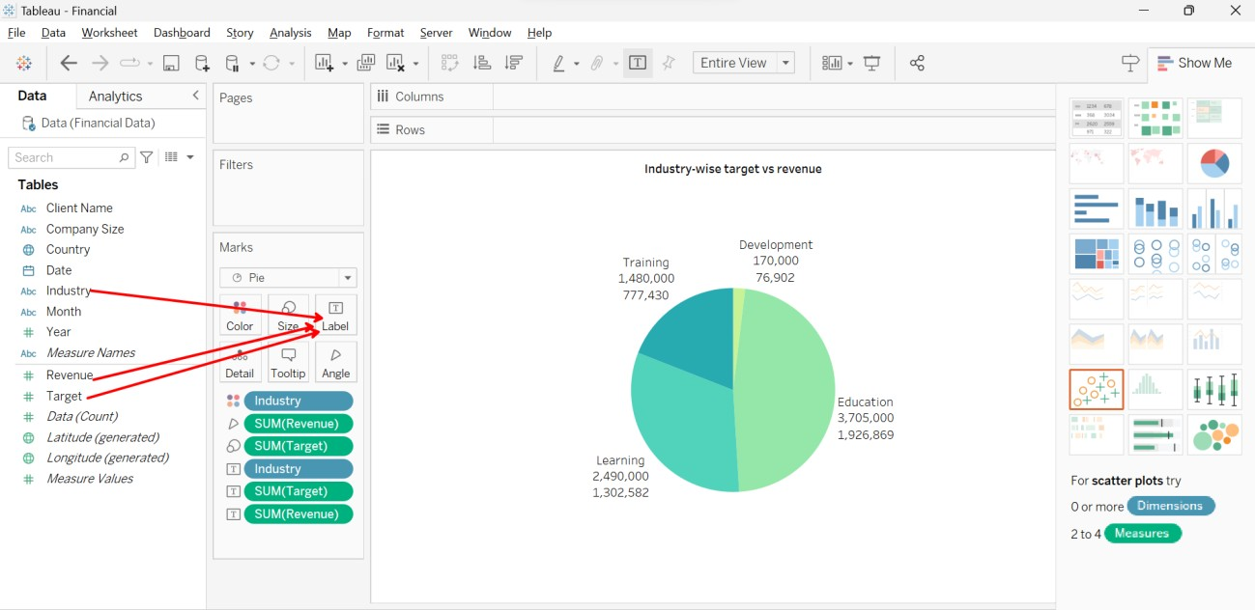

* 1. Make a table showing target revenue by country and actual revenue.

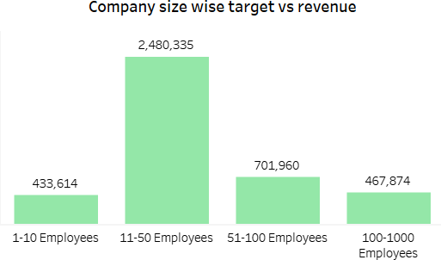

Like:

***Step1:*** *Drag the company size field into the column area*

***Step2:*** *Drag the Revenue field into the Rows area*

***Step3:*** *Measure Names into the Color*

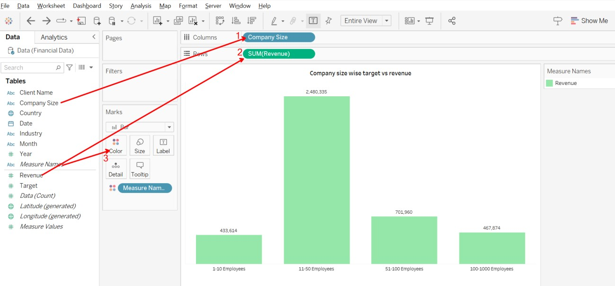

* 1. Make a line chart of that monthly revenue

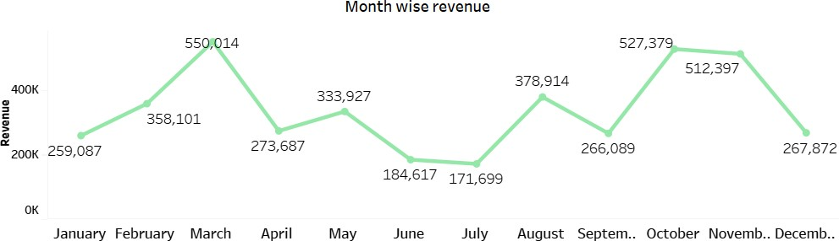

Like:

***Step1****: Drag the Date field into the Column area then*

***Step2****: Click on the + (Plus) sign, it will show Quarters again click on the + (Plus) sign then you will get Month*

***Step3****: Drag the Revenue field into the Rows area*

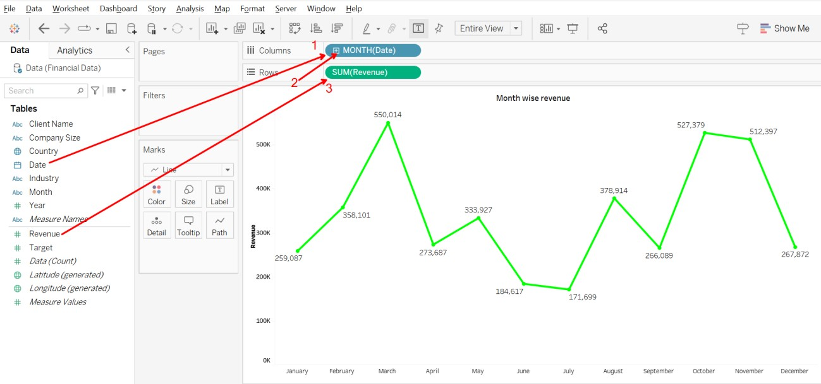

**Final Dashboard**

